PROCLAMATION

Mayors Alliance to End Childhood Hunger

WHEREAS, summer is the hungriest time of year for many children when families struggle to make up for lost school meals and food insecurity tends to increase; and

WHEREAS, 53 percent of school-aged kids—30 million in total—qualify for free or reduced-price school meals but don’t get these meals when school is out for the summer; and

WHEREAS, children who are food insecure are more likely to miss school, perform worse academically, experience social, emotional, and mental health challenges, forego healthcare, and develop chronic disease; and

WHEREAS, the Summer Electronic Benefit Transfer Program (Summer EBT) and Non-Congregate Summer Meals are proven, effective interventions that reduce food insecurity during the summer months and their implementation is a historic opportunity to reduce summer hunger; and

WHEREAS, since 2023, rural non-congregate meal service has allowed programs in certain rural areas to distribute grab-and-go or delivered meals to kids outside of the typically required group settings and permitted summer meals to be eaten off-site; and

WHEREAS, expanding non-congregate summer meal service to children and families in urban and suburban communities would promote equitable access to nutritious meals for millions of children, better meet families’ diverse needs, and further reduce summer food insecurity.

NOW THEREFORE, I, Melissa Elliott, Mayor of the City of Henderson, do hereby recognize that every child deserves access to nutritious meals during the summer months, and children should not be denied resources because of their household’s economic status or zip code and encourages Congress to expand access to non-congregate summer meals by extending eligibility to urban and suburban areas.

IN WITNESS WHEREOF, I have hereunto set my hand and caused to be affixed the Great Seal of the City of Henderson in the State of North Carolina this the 20th day of May 2024.

Melissa Elliott, Mayor

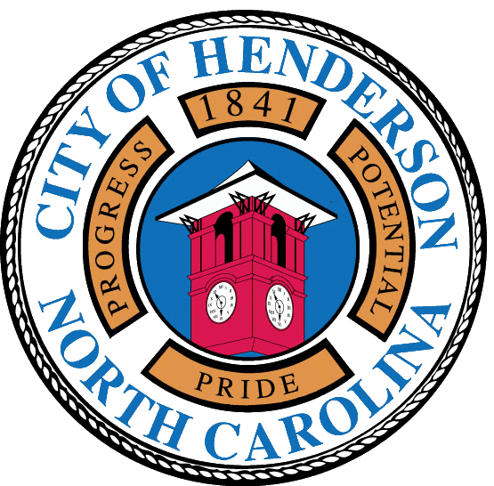
Attested by:

_______________________________
Tracey Kimbrell, City Clerk

